Security Alerts: Emergency Action Plans
Building Name: Oriental Institute, Pusey Lane
Building number: 191
Occupying departments: Asian and Middle Eastern Studies; Bodleian Library
Emergency Action Plans provide a framework to respond to incidents of:
- Non-fire building evacuation – e.g. Bomb threat, suspicious items or suspect devices
- Building invacuation or shelter – when a building provides protection against incidents taking place externally (e.g. smoke cloud, chemical cloud)
- Building lockdown – when action is taken to secure the building perimeter to prevent an external security incident from entering the building (e.g. a firearms incident)
In the event of a Security Alert the building Emergency Action Plans will be activated. The Emergency Action Plans should be reviewed and tested regularly
Building Incident Controller: Thomas Hall
Deputy: Trudi Pinkerton
The nominated building Group Leaders are:

• | Basement & Lobby: | Louise Smith, Nick Gibson, Julian Faultless, Student Invigilators
• | Library: | Lydia Wright, Lidio Ferrando, Invigilator
• | First Floor: | David Taylor, Jay Lewis, Yuhan Vevaina

- Second Floor Asli Niyazioglu

- Third Floor & IT/Think Tank Thomas Hall/David Rechter/ Christine Mitchell

The decision to activate any of the Emergency Action Plans will be as a result of the collaboration between the building’s Incident Controller, Security Services and the Police.
If immediate emergency action is required the Building Incident Controller will issue appropriate instructions and inform the Police on 999 and Security Services on 01865 (2)89999.
The incident will be declared over by the building Incident Controller, Security Services or the Police.

Appendix A: Emergency Action Plan – Bomb Threat, suspicious items and Suspect Packages
Appendix B: Emergency Action Plan – Building Invacuation and Shelter
Appendix C: Emergency Action Plan – Building Lockdown
Guidance: Armed incident – Be prepared Keep calm
Information sheet 1: Actions for Bomb threat, Suspicious Items and Suspect Devices
Information sheet 2: Actions for Building Invacuation or Lockdown, if people want to leave the building
Information sheet 3: Actions if the fire alarm is activated during a building Invacuation or Lockdown event.

Oriental Institute, Pusey Lane
Appendix A Emergency Action Plan - Bomb Threats, Suspect Packages and Evacuation
On receipt of a Bomb threat or discovery of a suspect package call the Police on ‘999’ to seek advice. After police assessment it may be necessary to issue a non-fire building evacuation instruction, as the situation evolves please follow these actions:
Immediate Actions:
- Establish the building Incident Controller(s) (Thomas Hall/Trudi Pinkerton)
- Establish a single point of contact for communication with Security Services and the Police
- Advise Security Services by calling: 01865 (2)89999 / 01865 (2)72944
- The Incident Controller should gather the department Emergency Action Team (nominated Group Leaders) to brief them on the emerging situation
- The nominated Group Leaders may instruct staff to inspect their working space for any unfamiliar bags or packages.
Communication: Thomas Hall, Lidio Ferrando (Library) or their deputies to inform staff by use of the megaphones that:
There is a security alert and they should gather together immediate personal belongings and be on standby in case there is a need to evacuate the building.
Advise all staff operating away from the building by email or text, or by Twitter @FAMESox, or Facebook @asian.and.middle.eastern.studies.oxford, that there has been a security alert and the building is closed. Administrative Assistant, Senior Academic Administrator, and Undergraduate and Graduate Administrators to send an email to their mailing lists informing them of a security alert and that the building is closed until further notice.
.

Further Actions: Check and Inform
- If unfamiliar or suspect package(s) are located this should be reported to the Floor Walker(s) or Incident Controller(s). Refer to: INFORMATION SHEET 1 – Actions for Suspicious Items or Suspect Devices
- If the decision is made to evacuate the building, staff should be notified by verbal instruction, using megaphones if necessary and be encouraged to remain calm, gather together essential personal belongings and wait for further instructions from the Incident Controller(s) or Floor Walker(s)
- The usual fire alarm muster point may be compromised. Therefore, instructions for a safe evacuation route should be sought from the Incident Controller, Security Services or the Police
People should not return to the building unless it is safe to do so.
Disabled/vulnerable people: Lecturers/class leaders (if the vulnerable person is a student) should provide appropriate assistance to these people. If their own safety is compromised this should be reported to the Group Leaders or Incident Controller. Group Leaders will check all rooms and assist as necessary. Staff and students with an active PEEP will be assisted by their appointed assistants.
Declaring the incident over: The Incident Controller, Security Services or the Police are authorised to declare the incident over.
After the incident: Group Leaders to check the building and report any irregularities.
Communication: Thomas Hall or deputy to send a communication to all relevant staff, by email and direct announcement at the assembly point advising that the incident is over and the building is now open.

Oriental Institute, Pusey Lane
Appendix A Emergency Action Plan - Bomb Threats, Suspect Packages and Evacuation

Call the Police on ‘999’
- Establish the department’s Incident Controller and single point of contact.
- Call Security Services on (2)89999 or (2)72944
- Incident Controller to brief the Emergency Action Team (Group Leaders)
- Inform staff there is a security alert, to gather their immediate personal belongings and standby in case there is a building evacuation.
- Inform staff operating away from the building that the building is closed.
• Staff may be asked to look for unfamiliar parcels or packages.

- Unfamiliar or suspect packages should be reported to the Emergency Action Team or Incident Controller.
- Updates and instructions to be provided by the Emergency Action Teams, Incident Controllers, Security Services or the Police

Oriental Institute, Pusey Lane
Appendix B Emergency Action Plan – Building Invacuation or Shelter
In the event of a decision by the building Incident Controller, Security Services or the Police to issue a building invacuation or shelter warning, quickly close all the external doors and windows and carry out the following actions:
Immediate Actions:
- Establish the building Incident Controller(s) (Thomas Hall/Trudi Pinkerton)
- Establish a single point of contact for communication with Security Services and the Police
- Advise Security Services by calling: 01865 (2)89999 / 01865 (2)72944
- The building’s Incident Controller should gather the department Emergency Action Team (nominated Group Leaders) to brief them on the emerging situation

Communication:
Thomas Hall, Lidio Ferrando (Library) or their deputies to inform staff by email, and by use of the megaphones that
- There is a security alert and they should not leave the building. Instruct them to close all nearby windows, remain calm and await further updates. Mobile phones switched to silent
Advise all staff operating away from the building by email or text, or by Twitter @FAMESox, or Facebook @asian.and.middle.eastern.studies.oxford, that there has been a security alert and the building is closed. Administrative Assistant, Senior Academic Administrator, and Undergraduate and Graduate Administrators to send an email to their mailing lists informing them of a security alert and that the building is closed until further notice.
- that there has been a security alert and the building is closed

Further Actions: Check and Inform
- Staff should close all external doors and windows
- Nominated Group Leaders to keep staff informed of emerging issues and encourage them to keep calm
- The Incident Controllers, Security Services or the Police may request staff in the building to move away from external facing doors and windows. In this event, staff should follow directions from the nominated Group Leaders or Incident Controller, who may instruct staff to move to the identified safe rooms (tbc) and await further instructions
People should not leave the building unless it is safe to do so
Non- University personnel: Non-University personnel may be directed to seek shelter in University buildings. If this happens the Incident Controller (through a member of the Emergency Action Team) or Security Services will direct them to the lecture theatre or other suitable space. The public will be supervised by Thomas Hall or deputy.
Person(s) wishing to leave the building: If people wish to leave the building. Refer to INFORMATION SHEET 2
Fire alarm activation: In the event of fire alarm activation during a building invacuation/shelter or lockdown event. Refer to INFORMATION SHEET 3
Disabled/vulnerable people: Lecturers/class leaders (if the vulnerable person is a student) should provide appropriate assistance to these people. If their own safety is compromised this should be reported to the Group Leaders or Incident Controller. Group Leaders will check all rooms and assist as necessary. Staff and students with an active PEEP will be assisted by their appointed assistants.
Declaring the incident over: The Incident Controller, Security Services or the Police are authorised to declare the incident over.

After the incident: Group Leaders to check the building and report any irregularities.
Communication: Thomas Hall or deputy to send a communication to all relevant staff, by email and direct announcement at any assembly point, advising that the incident is over and the building is now open.

Oriental Institute, Pusey Lane
Appendix B Emergency Action Plan – Building Invacuation or Shelter

Quickly close all the external doors and windows
- Establish the department’s Incident Controller and single point of contract
- Call Security Services on (2)89999 or (2)72944
- Incident Controller to brief the Emergency Action Team
- Inform staff in the building that an external incident has occurred and to remain in the building
- Inform staff operating away from the building that it is closed
- Inform staff to close all external windows and doors
- Updates and instructions to be provided by the Emergency Action Team, Incident Controller, Security Services or the Police

Oriental Institute, Pusey Lane
Appendix C Emergency Action Plan - Building Lockdown
In the event of a decision by the building Incident Controller, Security Services or the Police to lockdown a building, quickly secure entrance doors to restrict access or egress to the building and carry out the following actions:
Immediate Actions:
- Establish the department Incident Controller (Thomas Hall )
- Establish a single point of contact for communication with Security Services and the Police
- Advise Security Services by calling: 01865 (2)89999 / 01865 (2)72944
- The building’s Incident Controller should gather the department Emergency Action Team (nominated Group Leaders) to brief them on the emerging situation
Communication:
Thomas Hall, Lidio Ferrando (Library) or their deputies to inform staff by use of the megaphones and by email that:
- There is a security alert the building is now locked and they should not leave the building. Instruct them to close all nearby windows, remain calm and await further updates.
Advise people operating away from the building by email or text, or by Twitter @FAMESox, or Facebook @asian.and.middle.eastern.studies.oxford, that there has been a security alert and the building is closed. Administrative Assistant, Senior Academic Administrator, and Undergraduate and Graduate Administrators to send an email to their mailing lists informing them of a security alert and that the building is closed until further notice.
- that there has been a security alert and the building is closed.
Further Actions: Check and inform
- Group Leaders to secure and supervise external doors (front, side, and library) in case an immediate evacuation is required
- Staff to close all the external windows
- Thomas Hall/Trudi Pinkerton to keep staff informed of the emerging situation
- The Incident Controller, Security Services or the Police may request that staff in the building move away from all external facing doors and windows, in this event staff should follow directions from the nominated Group Leaders or Incident Controller, who may instruct staff to move to the safe rooms (tbc) and wait for further instructions
People should not leave the building unless it is safe to do so
Person(s) wishing to leave the building: If people wish to leave the building. Refer to INFORMATION SHEET 2
Fire alarm activation: In the event of fire alarm activation during a building invacuation/shelter or lockdown event. Refer to INFORMATION SHEET 3
Disabled/vulnerable people: Lecturers/class leaders (if the vulnerable person is a student) should provide appropriate assistance to these people. If their own safety is compromised this should be reported to the Group Leaders or Incident Controller. Staff and students with an active PEEP will be assisted by their appointed assistants. Group Leaders will check all rooms and assist as necessary.
Declaring the incident over: The Incident Controller, Security Services or the Police are authorised to declare the incident over.
After the incident: Group Leaders to check the building and report any irregularities.
Communication: Thomas Hall or deputy to send a communication to all relevant staff, by email and direct announcement at any assembly point, advising that the incident is over and the building is now open.

Oriental Institute, Pusey Lane
Appendix C Emergency Action Plan - Building Lockdown

Quickly secure the external entrance doors
- Establish the department’s Incident Controller(s) and single point of contact
- Call Security Services on (2)89999 or (2)72944
- Incident Controller(s) to brief the Emergency Action Team
- Inform staff that the building is locked because of an external security incident
- Staff should not leave the building
- Close all external windows and doors
- Updates and instructions to be provided by the Emergency Action Team, Incident Controller(s), Security Services or the Police

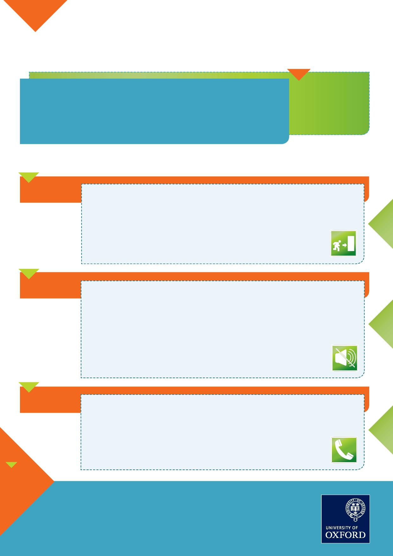
What to do in the event of an attack
by an armed person or persons
In the event of an incident, quickly determine the best way to protect yourself:
Evacuate
u If it is possible to do so safely, exit the building or area immediately
u Have an escape route in mind (Fire Exit signs are a good point of reference)
u Evacuate regardless of whether others agree to follow
u Help others, if possible
u Prevent others from entering the area of danger
u Do not attempt to move wounded people
u When you are safe, call 999 and ask for the police
u If evacuation is not possible, find a place to hide where the offender
is less likely to find you
u If you are in a room/office, stay there
u If you are in a corridor, get into a room/office
u Lock the door and blockade it with furniture
u Silence your mobile phone and remain quiet
u Turn off the lights and draw any blinds
u Hide out of view and behind something solid (desk or cabinet)
u If it is possible to do so safely, call 999 and ask for the police
Hide
Stay SAFE
Inform
Further information and advice is available from Oxford University Security Services
01865 (2) 72944
security.control@admin.ox.ac.uk
When you contact the police provide the following information:
u Location of and the number of offenders
u Any physical descriptions of the offenders
u Number and type of weapons used by the offenders
u Number of potential victims at the location
u Your location
The purpose of this guidance is to alert and not to alarm –
it is not being provided in response to any specific information.
Staff and students should remain alert to the danger of terrorism
but should not let the fear of terrorism stop them from going
about their day-to-day life as normal.
Be PREPARED Stay CALM

Emergency Action Plan
Bomb threat, Suspicious Items and Suspect Devices
INFORMATION SHEET 1
Identify items that should not be there, cannot be accounted for or are out of place
In the unlikely event that you are handling a suspect package you should place it on a flat surface, DO NOT place it in the corner of a room or in a container.
Actions - if a suspicious object is found DON’T
- Touch or move it
- Open it
- Let others interfere with it
- Touch any light switches
DO
- Keep calm
- Leave a distinctive marker near (not touching) the suspect package
- Move away from the suspect package
- Try to leave a trail for the emergency services to easily locate the suspect package
- Evacuate to adjacent rooms
- Call the Police (999) and Security Services on the emergency number 01865 (2)89999
Actions - if dealing with a confirmed suspicious item/obvious bomb:
Call the Police on 999 and Security Services on the emergency number 01865 (2)89999. Move yourself and anyone nearby to an area which is:
- Not in the direct line of sight of the item
- More than 100m away from a small item
- Behind hard cover i.e. a solid object
The Police or Security Services will provide further advice on safe distances, cordons and assembly points

Emergency Action Plan
Building Invacuation/Shelter or Building Lockdown
INFORMATION SHEET 2
Dealing with a person wishing to leave the building:
The person wishing to leave the building should be encouraged to stay until the event happening outside the building is declared over.
If they still wish to leave, they should be advised that:
▪ A Security Alert has been declared and people are being advised to remain in the building for their own safety, however, if they choose to leave they could be in imminent danger of being harmed
If the person insists on leaving the building:
▪ The person cannot be stopped from leaving the building, but the department’s Incident Controller or Group Leaders should be informed as soon as possible so that they can advise the emergency services
▪ In the event of building lockdown the person should be allowed to exit the building through an agreed exit point in a controlled way

Emergency Action Plan
Fire Alarm activation during building invacuation/shelter or lockdown event.
INFORMATION SHEET 3
The risk presented by the cause of the security event, may well be greater than the risk presented by the cause of the fire alarm actuation.
If the fire alarm activates during a shelter or lockdown event, and you have a delay programmed into you fire alarm panel, consider the following actions:
- Follow your fire emergency procedures and investigate as usual.
- If a fire is confirmed, consider if it is possible to initially move people to areas of relative safety within the building, away from the fire location.
- If a full evacuation is necessary, consider using the security alert switch on your fire alarm panel; remember the fire assembly point may not be a safe location.
If the fire alarm activates during a shelter or lockdown event, and you do not have a delay programmed into you fire alarm panel, consider the following actions:
- Silence the alarm at the panel.
- Check the fire alarm panel to locate the activation point.
- Check the area to see if there is a fire at that location.
- If a fire is confirmed, consider if it is possible to initially move people to areas of relative safety within the building, away from the fire location.
- If a full evacuation is necessary, use the security alert switch on your fire alarm panel; remember the fire assembly point may not be a safe location, and the alert switch will over-ride the silencing of the alarm.
If possible inform OUSS of your actions and decisions, by radio, mobile phone or landline, OUSS may be able to advice on a safe escape route.
False fire alarm activation - efforts should be made to re-secure the external doors that may have failed ‘open’ as a result of the alarm activation.
Inform OUSS of your actions and decisions.

